Handout for Direct Speech
vgorman1@unl.edu

First and Second Person Personal Pronouns

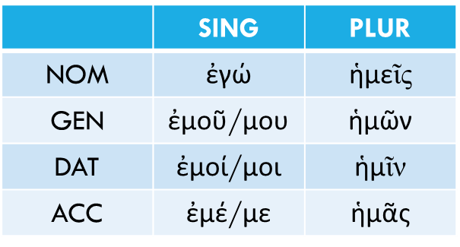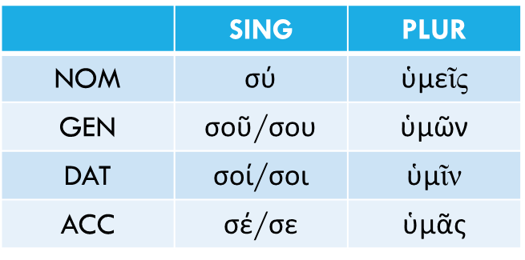

Reflexive Singular

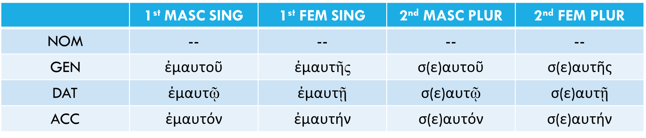

Reflexive Plurals

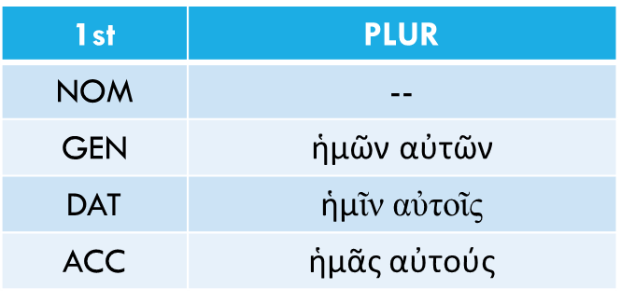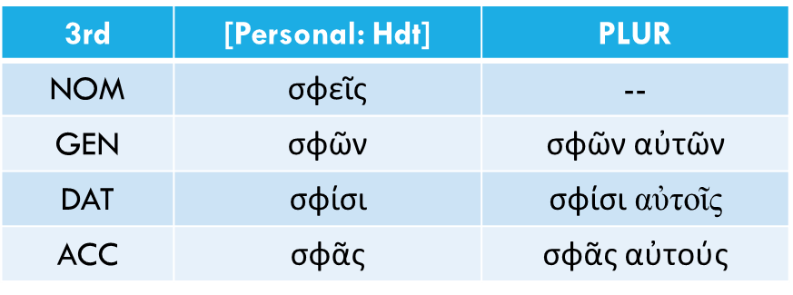

Possessives adjectives

ἐμός, ἐμή, ἐμόν = my
σός, σή, σόν = your, yours (singular)
ἡμέτερος, -τέρα, τερον = our, ours
ὑμέτερος, -τέρα, τερον = your, yours (plural)
σφέτερος, -τέρα, τερον = their

Summary of Verbs Moods in Independent Clauses

- Imperative Mood. “Go to war!” in the 2nd and 3rd person
- Independent Optative [note: to opt for something is to wish for it]
  - Potential (with ἄν). “We might go to war.”
  - Wish (without ἄν). “May we go to war!”
- Independent Subjunctive [unreal]
  - Hortatory in 1st person [= commands in 1st person] “Let us go to war.”
  - Deliberative in 1st person questions. “Should we go to war?”
  - Prohibitive in 2nd person (with μή). “Do not go to war!”

